|  |  |  |
| --- | --- | --- |
| Ain Shams University  Faculty of Computer &  Information Sciences  Credit Hours New Programs  Accredited Faculty | **QS LOGO** | جامعة عين شمس  كلية الحاسبات والمعلومات  البرامج جديدة للتعليم العالي  بنظام الساعات المعتمدة  كلية معتمدة |

**Computer Interface & Peripherals (CHW 460)**

**Home automation Based Arduino Project**

**Report**

|  |  |  |
| --- | --- | --- |
| **Member name** | **Student’s ID** | **Department** |
| 1. Mariam Mahmoud Hussien | 2018170808 | Bioinformatics |
| 1. Mariam Hesham El Sayed | 2018170810 | Bioinformatics |
| 1. Sara Sameh Mousa | 2018170748 | Bioinformatics |
| 1. Esraa Salah Elden | 2018170712 | Bioinformatics |
| 5.Ammar Atef | 2018170777 | Bioinformatics |

**Table of content**

**1. Introduction**

**2. Describe the main components and connection with arduino**

**1. LCD**

**2. MQ2 Gas sensor**

**3. hc-05 Bluetooth**

**4. LM35 (Temperature Sensor)**

**5.** **MAX30102 Heart Rate Sensor**

**3. Describe implementation of code and list of functions**

1. **Introduction**

Nowadays, we have remote controls for our televisions and other electronic systems, which have made our lives easy. Have you ever wondered about home automation which would give the facility of controlling lights, doors and other electrical appliances at home using a remote control? Off-course, Yes! But are the available options cost-effective?

We have come up with a new system called Arduino based home automation using Bluetooth. This system is super-cost effective and can give the user, the ability to control any electronic device without even spending for a remote control. This project helps the user to control all the electronic devices using his/her smartphone. Time is a very valuable thing. New technologies are being introduced to save our time. To save people’s time we are introducing Home Automation system using Bluetooth. With the help of this system, you can control your home appliances from your mobile phone within the range of Bluetooth.

The main idea here is to build a smart home using Arduino that can control and monitor the home environment and electrical devices like light, doors and monitoring the heat temperature, detect smoke and measure heart rate.

In this device there are several main parts such as Arduino, Bluetooth module, Heart sensor, servo motor, temperature sensor and android application.

2.1.LCD

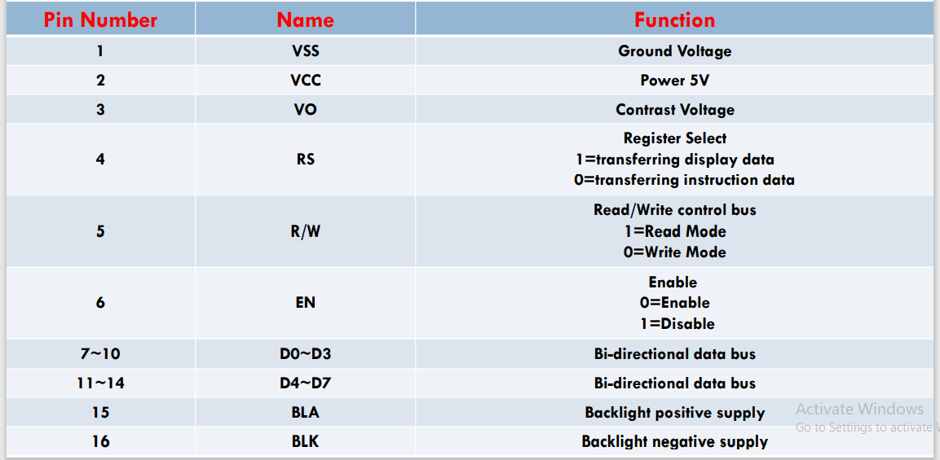

LCD library and parameters in arduino IDE

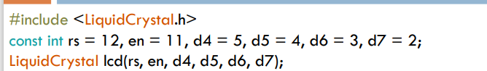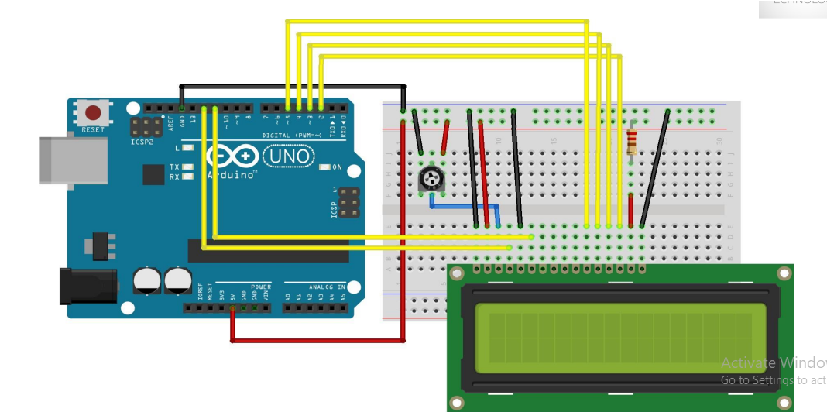

2.2. **MQ2 Gas sensor**

It can detect LPG, Smoke, Alcohol, Propane, Hydrogen, Butane, Methane and Carbon Monoxide concentrations anywhere from 200 to 10000ppm.

The analog output voltage provided by the sensor changes in proportional to the concentration of smoke/gas. The greater the gas concentration, the higher is the output voltage; while lesser gas concentration results in low output voltage.

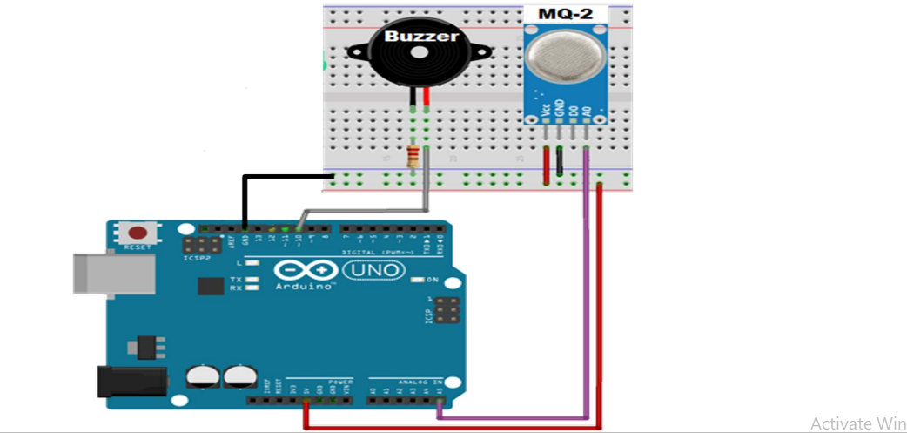

Figure 1Sensor and Buzzer connections with arduino.

**2.3.Bluetooth**

This Bluetooth module covers 9 meters (30ft) ,Operating Voltage 4V to 6V (Typically +5V) ,Operating Current 30mA.

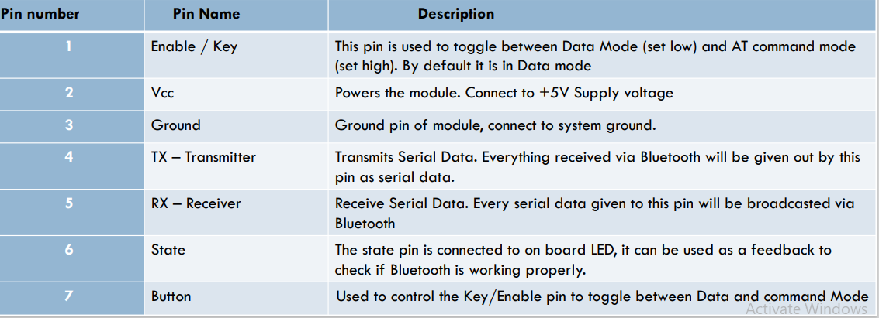

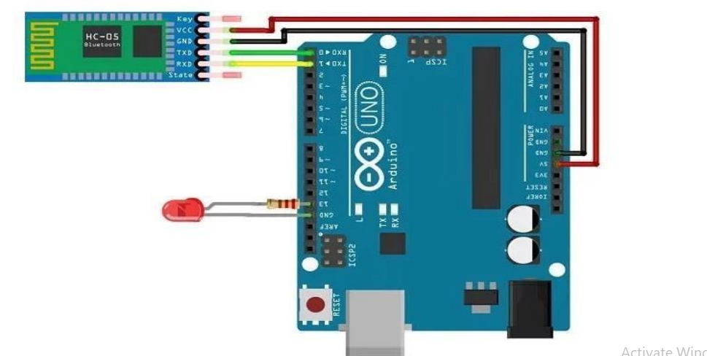

Figure 2 Bluetooth connection with arduino

**2.4.LM35(Temperature Sensor )**

LM35 is a temperature measuring device having an analog output voltage proportional to the temperature, It provides output voltage in Centigrade (Celsius). It does not require any external calibration circuitry, The sensitivity of LM35 is 10 mV/degree Celsius. As temperature increases, output voltage also increases. E.g. 250 mV means 25°C, It is a 3-terminal sensor used to measure surrounding temperature ranging from -55 °C to 150 °C.

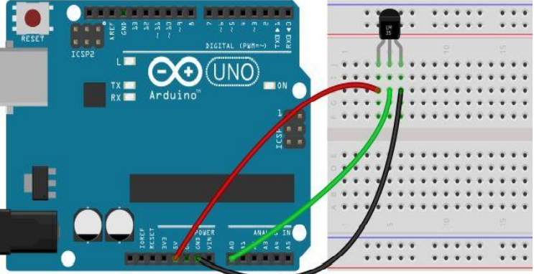

Figure 3 LM35 connection with arduino

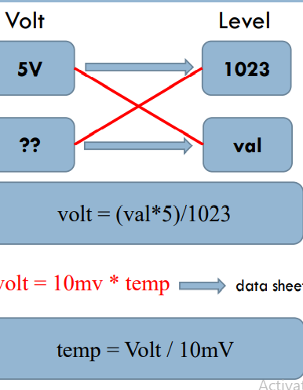

Figure 4 Volt Conversion to calculate the temperature in Celsius

**2.5. MAX30102 Heart Rate Sensor**



Figure 5 libraries to use Heart sensor in arduino code

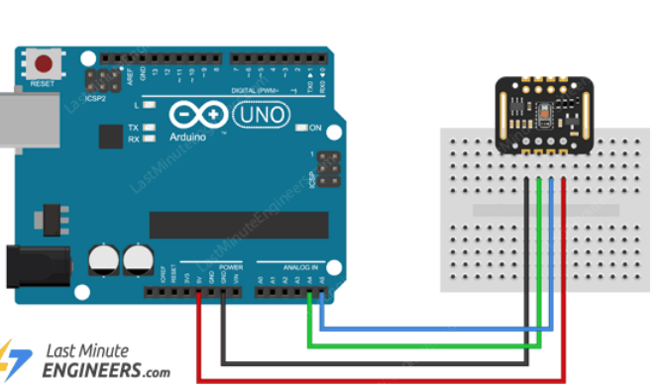

Figure 6 connection with arduino

1. **Implementation**

There are three functions

**1-LCD_Check_pass**

Receive string password from user application then check if the password right will print “Right password” and open the door .

If the password is wrong will print “wrong password ”,if user enter the password wrong for three times the counter will block user to enter password for 3 seconds.

**2-control_Bluetooth**

Receive char from user to open or close the Led and open or close the door.

**3-Sensors**

Check the analog value from sensor MQ2 if it’s value more than 150

This means that smoke detected so, Buzzer on and the door will open.

Check the analog value from sensor LM35, if it’s value more than 50 the door will open.

Print the heart rate value.